**Chapter I - Data Flow Diagram (existing system)**

**Level 0**

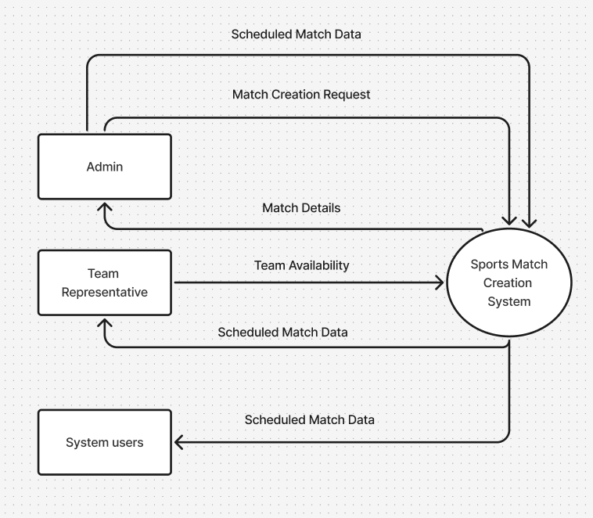

1. **An Admin decides that a new sports match needs to be created and sends a Match Creation Request to the Sports Match Creation System.**
2. **The Sports Match Creation System needs to know when teams can play. It relies on Team Representatives to provide their Team Availability information.**
3. **Using the Match Creation Request and Team Availability, the Sports Match Creation System performs its core function: it processes this data to determine optimal match times, allocate teams, and finalize the match details.**
4. **Once a match is created and scheduled, the Sports Match Creation System sends detailed information (Match Details) back to the admin for their administrative records.**
5. **Finally, the system publishes the Scheduled Match Data to all relevant parties: the Admin, the Team Representatives, and general System Users, so everyone is informed about the upcoming games.**

**Level 2**

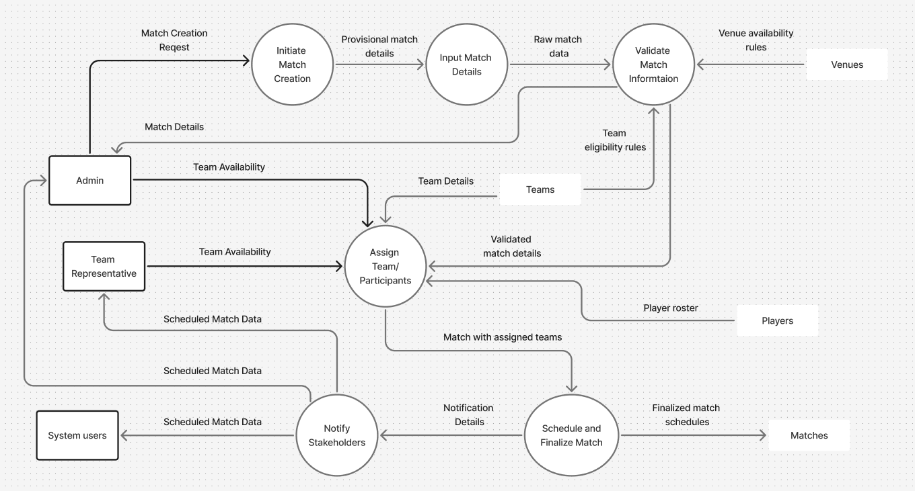

1. **Match Request: An Admin (administrator) starts the process by requesting a new match. This initial request creates some basic, preliminary details for the match.**
2. **Adding Details: The system then gathers more specific information for this match. The admin also provides more detailed input at this stage to refine the match's parameters. Once all these initial details are in, they become the "raw" match information.**
3. **Checking the Match: Before proceeding, the system carefully checks this raw match information. It looks at rules about Venues (to see where and when a game can be played) and Teams (to make sure the right teams are available and eligible). The admin also offers general team availability information to help with this check. After all checks pass, the match details are confirmed as valid.**
4. **Assigning Teams: With validated match details, the system moves on to assigning teams. This is a crucial step where Team Representatives provide their specific team availability (when their teams can actually play). The system also pulls up team rosters and details from records to help with this assignment. Once teams are successfully allocated, the match now has its participants.**
5. **Finalizing and Announcing: The system then takes the match with assigned teams and officially schedules it. This final schedule is recorded in the system's match history. At the same time, the system prepares to send out notifications. Finally, it sends out the completed match schedule to everyone who needs to know: the Admin, the Team Representatives, and all other System Users.**

**Chapter III - Data Flow Diagram (DFD)**

**Level 0**

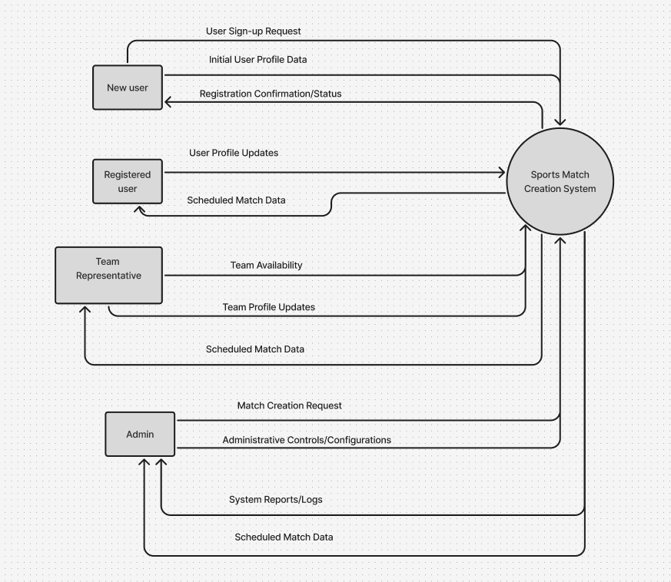

1. **New People Joining: Someone new who wants to use the app signs up by sending their details. The app then confirms their registration.**
2. **Regular Users:**

* **Players or Individuals: People who've signed up can update their personal information. They mainly use the app to see the schedule of upcoming matches.**
* **Team Managers: These are users responsible for a team. They tell the app when their team is free to play and can update their team's details. In return, they get the match schedule specific to their team.**

1. **The Administrator: The person in charge (the Admin) tells the app to create new matches and uses it to control various settings. The app then gives the Admin details about the matches and reports on how things are running.**

**Level 1**

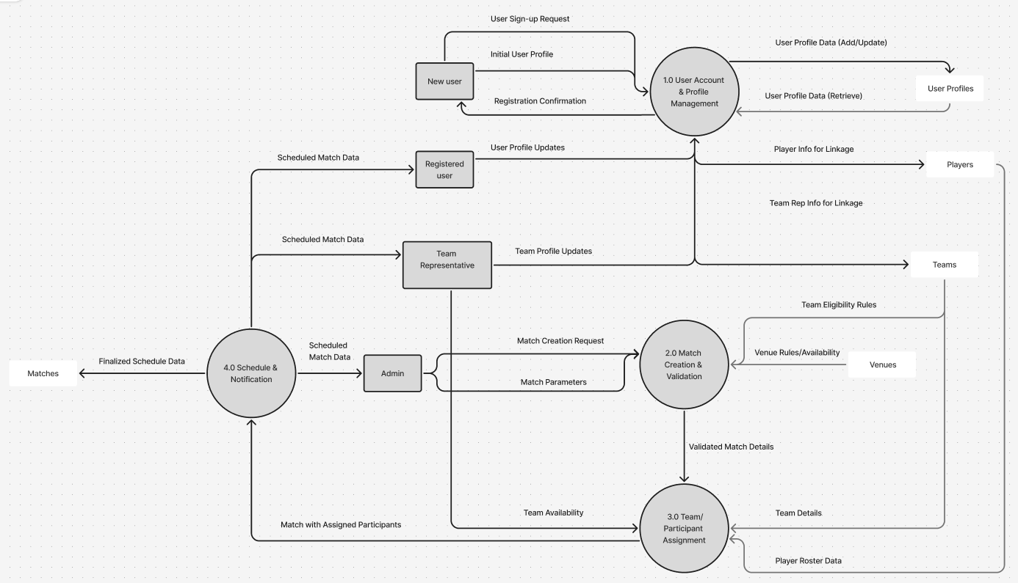

**1. Managing User Accounts and Profiles: This part of the app is where it all begins for users.**

* **When someone new wants to join, they send their sign-up request and personal information here. The app then confirms their registration.**
* **Once registered, both individual players and team managers can come back to this part to update their personal profiles (like contact details or preferences).**
* **This section also links the registered user's profile to their specific role, whether they are a player or a team manager, and stores all this user information in a central User Profiles record. These links are important because they connect user accounts to actual players and teams.**

**2. Creating and Checking Matches: This is where the idea for a new match starts and gets verified.**

* **The Admin sends a request to this part of the app to set up a new match, providing all the necessary details.**
* **This section then checks against records of Venues (to make sure there's a place to play) and Teams (to ensure teams are eligible to participate).**
* **After all checks pass, this part of the app produces a set of confirmed match details, ready for the next step.**

**3. Assigning Teams and Players: Once a match is confirmed as valid, this part of the app focuses on who will play.**

* **Team Managers provide their team's availability (when they can play) to this section.**
* **This part of the app also looks up details from Teams and Players records (which are populated by the account management section) to help assign the right participants to the match.**
* **Once everyone is assigned, this section creates a match complete with all its participants.**

**4. Scheduling and Notifying Everyone: This is the final stage where matches are officially scheduled and announced.**

* **The match with assigned participants is sent here. This part of the app then finalizes the schedule and saves it in the Matches record.**
* **Crucially, this section is responsible for sending out the finalized schedule:** 
  + **Players and Individual Users get a general view of the scheduled matches.**
  + **Team Managers receive specific updates about their team's upcoming games.**
  + **The Admin also gets the final schedule for their oversight.**